EXPT NO : 5(a) Implementation of NaïveBayes using Navie classifier methods

AIM:
To construct and implement Navie bayes using Navie classifier methods using Python.
Algorithm
1. The code starts by loading the iris dataset.
2. The data is then split into a training and test set of equal size.
3. Next, a Gaussian Naive Bayes classifier is trained using the training set.
4. Then predictions are made on the test set with accuracy scores calculated for each prediction.
5. Finally, a confusion matrix is created to show how well each prediction was classified as correct or incorrect
6. The code is used to train a Gaussian Naive Bayes classifier and then use it to make predictions.
7. The code prints the model's predictions, as well as the test set's output for comparison.
Program:
from sklearn import datasets
from sklearn.metrics import confusion_matrix, accuracy_score
from sklearn.model_selection import train_test_split
from sklearn.naive_bayes import GaussianNB
# Load the Iris dataset
iris = datasets.load_iris()
X = iris.data
Y = iris.target

# Split the dataset into training and testing sets
X_train, X_test, Y_train, Y_test = train_test_split(X, Y, test_size=1/3, random_state=42)

# Train a Gaussian Naive Bayes classifier
model = GaussianNB()
model.fit(X_train, Y_train)

# Make predictions on the test set
model_predictions = model.predict(X_test)

# Print predictions and actual labels
print("\nPredictions:", model_predictions)
print("\nActual labels:", Y_test)

# Calculate and print the accuracy score
accuracyScore = accuracy_score(Y_test, model_predictions)
print("\nAccuracy Score:", accuracyScore)

# Create and print the confusion matrix
cm = confusion_matrix(Y_test, model_predictions)
print("\nConfusion Matrix:\n", cm)

Output:
Predictions: [1 0 2 1 1 0 1 2 1 1 2 0 0 0 0 2 2 1 1 2 0 2 0 2 2 2 2 2 0 0 0 0 1 0 0 2 1
0 0 0 2 1 1 0 0 1 1 2 1 2]

Actual labels: [1 0 2 1 1 0 1 2 1 1 2 0 0 0 0 1 2 1 1 2 0 2 0 2 2 2 2 2 0 0 0 0 1 0 0 2 1
0 0 0 2 1 1 0 0 1 2 2 1 2]

Accuracy Score: 0.96

Confusion Matrix:
[[19 0 0]
[ 0 14 1]
[ 0 1 15]]

Result

Thus the program to implement Naïve Bayes Model is implemented and executed successfully

EXPT NO : 5(b) Implementation of Bayesian Network using Python

Aim
To construct and implement Bayesian Network using Python.
Algorithm
- Open command prompt and type, pip install torch torchvision torchaudio.!pip install torchbnn in a command prompt in python idle.
- Import Libraries: Import necessary libraries, including torch, torchbnn, datasets from sklearn, and matplotlib.
- Load Dataset: Load the Iris dataset using datasets.load_iris() and prepare the data and target as tensors using torch.from_numpy().
- Create Model: Define a Bayesian Neural Network model using bnn.BayesLinear layers and nn.ReLU() activation function.
- Define Loss Functions: Set up the cross-entropy loss function and Kullback-Leibler (KL) divergence loss using nn.CrossEntropyLoss() and bnn.BKLLoss().
- Initialize Optimizer: Use the Adam optimizer with a learning rate of 0.01 to update the model parameters.
- Training Loop: Run a loop for 3000 steps, where for each step, the model is fed the data tensor, and the losses (cross-entropy + KL divergence) are calculated.
- Backward Pass: Backpropagate the total loss and update the model parameters using optimizer.step().
- Compute Accuracy: After the loop ends, compute the model's accuracy by comparing predicted values with the actual target values.
- Output Final Results: Print the final accuracy, cross-entropy loss, and KL divergence after training.
- Plot Results: Define a function to plot two subplots, one showing the true labels and the other showing the predicted labels for visual comparison.
Program:
import numpy as np
from sklearn import datasets
import torch
import torch.nn as nn
import torch.optim as optim
import torchbnn as bnn
import matplotlib.pyplot as plt

# Load Iris dataset
dataset = datasets.load_iris()
data = dataset.data
target = dataset.target

# Convert dataset to PyTorch tensors
data_tensor = torch.from_numpy(data).float()
target_tensor = torch.from_numpy(target).long()

# Define the Bayesian Neural Network model
model = nn.Sequential(
bnn.BayesLinear(prior_mu=0, prior_sigma=0.1, in_features=4, out_features=100),
nn.ReLU(),
bnn.BayesLinear(prior_mu=0, prior_sigma=0.1, in_features=100, out_features=3)
)

# Define the loss functions
cross_entropy_loss = nn.CrossEntropyLoss()
klloss = bnn.BKLLoss(reduction='mean', last_layer_only=False)

# Define the optimizer
optimizer = optim.Adam(model.parameters(), lr=0.01)

# Training loop
for step in range(3000):
# Forward pass
models = model(data_tensor)

# Calculate Cross Entropy and KL loss
cross_entropy = cross_entropy_loss(models, target_tensor)
kl = klloss(model)

# Total cost
total_cost = cross_entropy + 0.01 * kl

# Backward pass
optimizer.zero_grad()
total_cost.backward()
optimizer.step()

# Final prediction and accuracy calculation
models = model(data_tensor)
_, predicted = torch.max(models.data, 1)
correct = (predicted == target_tensor).sum()
accuracy = 100 * float(correct) / target_tensor.size(0)

# Final output
cross_entropy = cross_entropy_loss(models, target_tensor)
kl = klloss(model)

print(f"Final Accuracy: {accuracy:.2f}%")
print(f"Final CE: {cross_entropy.item():.2f}, Final KL: {kl.item():.2f}")

# Function to plot the results
def draw_graph(predicted):
fig = plt.figure(figsize=(16, 8))
fig_1 = fig.add_subplot(1, 2, 1)
fig_2 = fig.add_subplot(1, 2, 2)

# Plot the true labels
z1_plot = fig_1.scatter(data[:, 0], data[:, 1], c=target, marker='v')
# Plot the predicted labels
z2_plot = fig_2.scatter(data[:, 0], data[:, 1], c=predicted)

plt.colorbar(z1_plot, ax=fig_1)
plt.colorbar(z2_plot, ax=fig_2)

fig_1.set_title("REAL")
fig_2.set_title("PREDICT")
plt.show()

# Final predictions and plot
draw_graph(predicted)

Output:
Final Accuracy: 96.67%
Final CE: 0.06, Final KL: 3.21
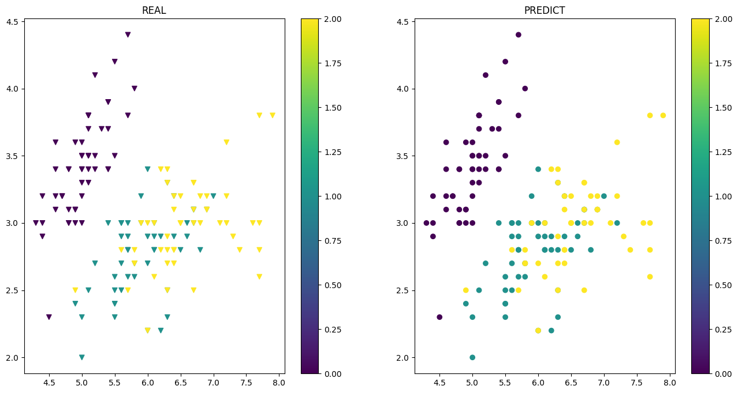

Result

Thus, the program to implement Bayesian Networks and perform inferences is implemented and executed successfully

